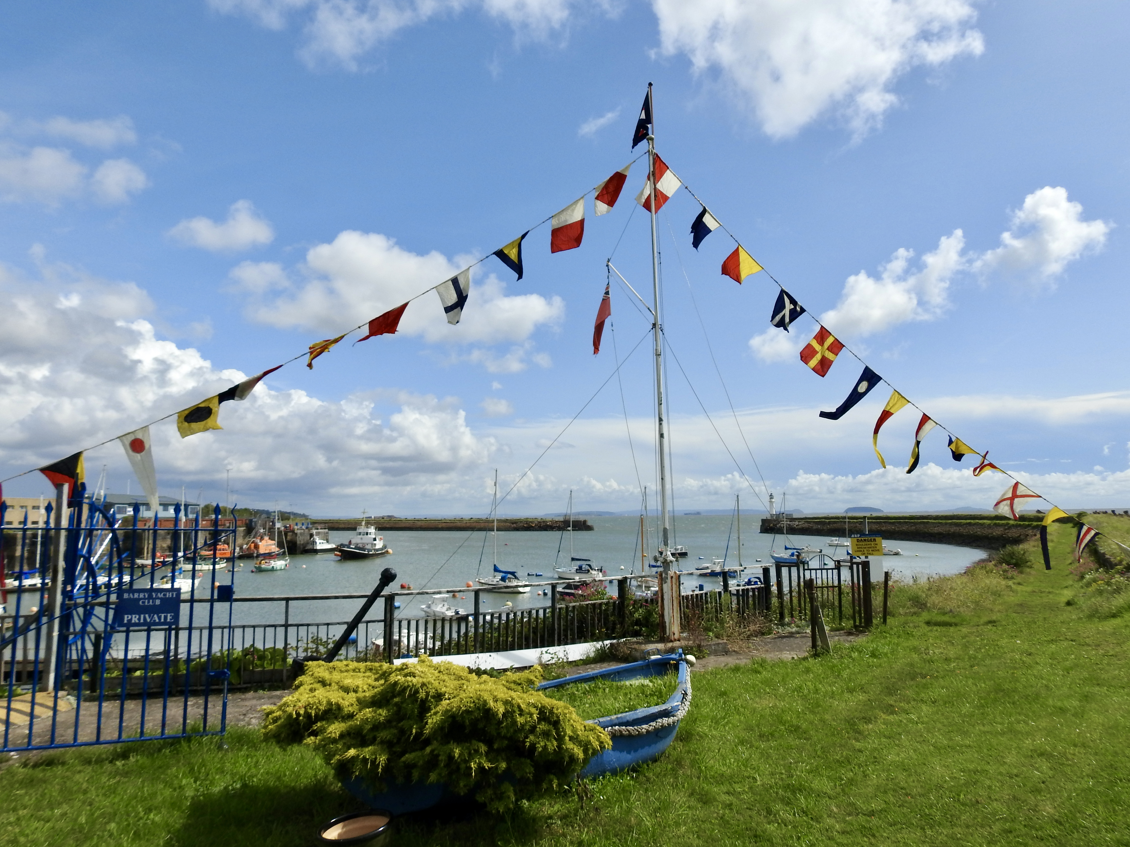
It’s time to join the BYC 💯 Club now in its 6th successive year. With very generous monthly payouts -

£200 Top prize!
£100 Second prize!
£50 Third/fourth prizes!
£25. Fifth/sixth prizes!

To join this great event which begins in March 2024 and runs until Feb 2025, members please contact Karen Donkin via the secretary@barryyachtclub.co.uk

Proposed 100 Club 2024/2025
Prize structure.
EVERY MONTH prizes to the value of £450 drawn back to the 12 winning participants.
1@ £200
1@ £100
2@ £50
2@ £25
This is a way to support your club, with a chance to get your money, plus more back.
As there will only be a limited number of tickets available (100) the odds of winning are loads better than the Lottery !

The year will start in March 2024 & you MUST be a member of BYC to participate. All tiers of membership inclusive.

Payment plan 1.
1 payment of £54 In November 2023.
1 payment of £50 in Dec 2023

Payment plan 2.
1 payment £44 November.
1 payment £30 December.
1 payment £30 January.
will ensure your number will be included in the March 2024 draw.

Alternatively, a single payment of £104 made out to Barry Yacht Club reference 💯 Cub.

HSBC

40-09-15

51589741

BYC Reference 100 Club

£104 payable.

Either drop a cheque into secretary’s office or by BACS transfer (Don’t forget to reference 100 Club)

Should you cease to be a member of BYC, your number will be invalidated.

